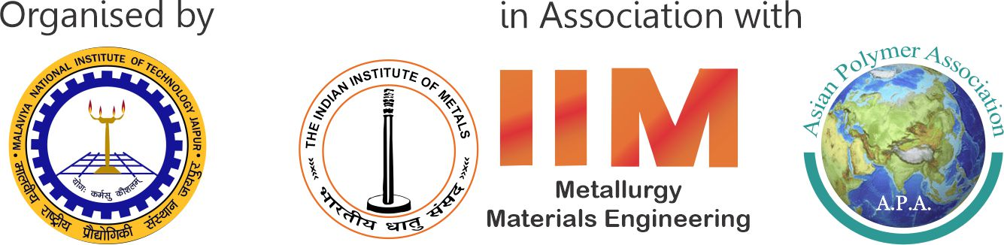
International Conference on
Advanced Materials for Sustainable Development
(ICAMSD-2025)
28-29 March 2024 | Jaipur, India
Date:

STUDENT REGISTRATION MANDATORY DECLARATION

I certify that
will be full time student at the time of conference.

Institute

Head of Department

Signature & Stamp

